## Important Scenarios

Registration

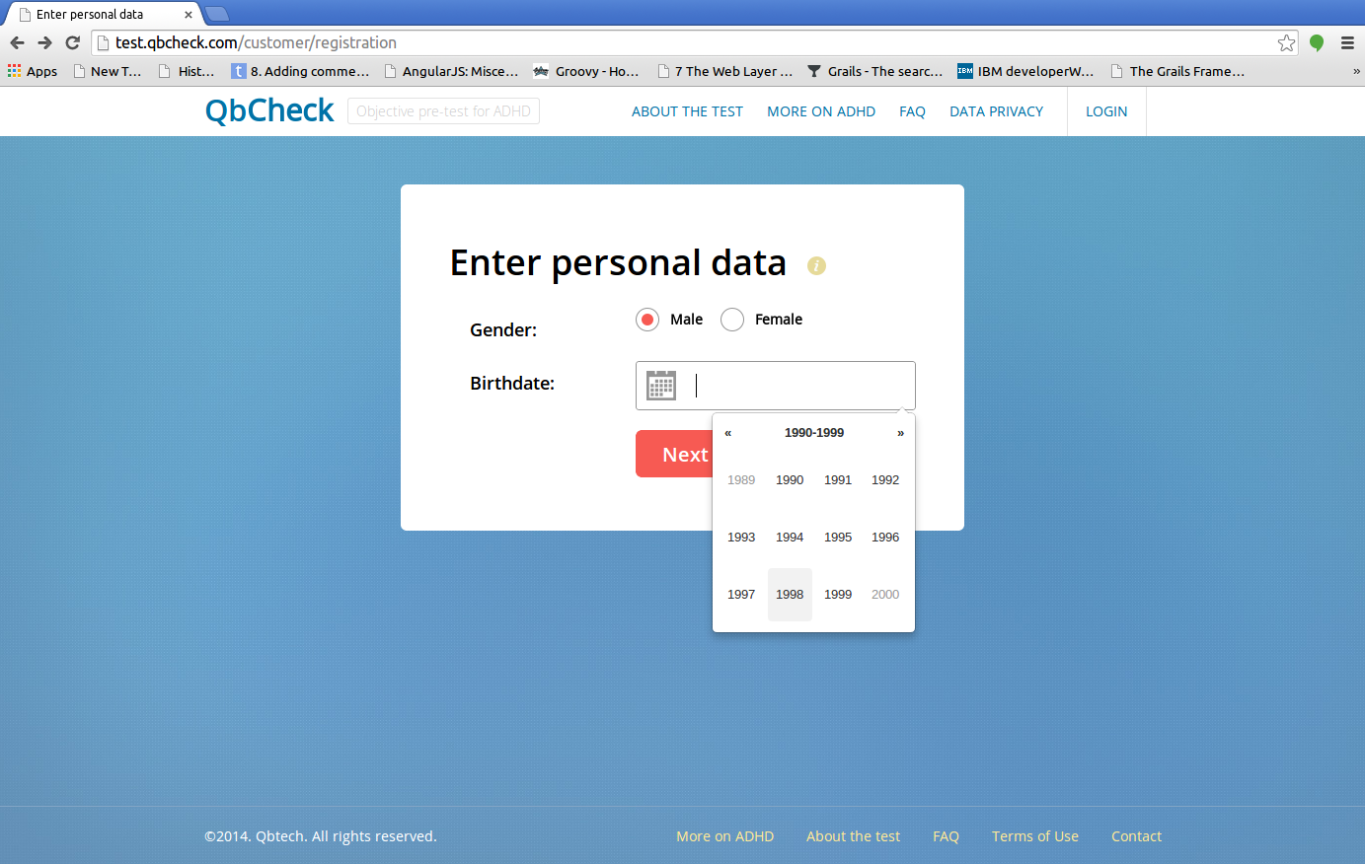

Questionnaire

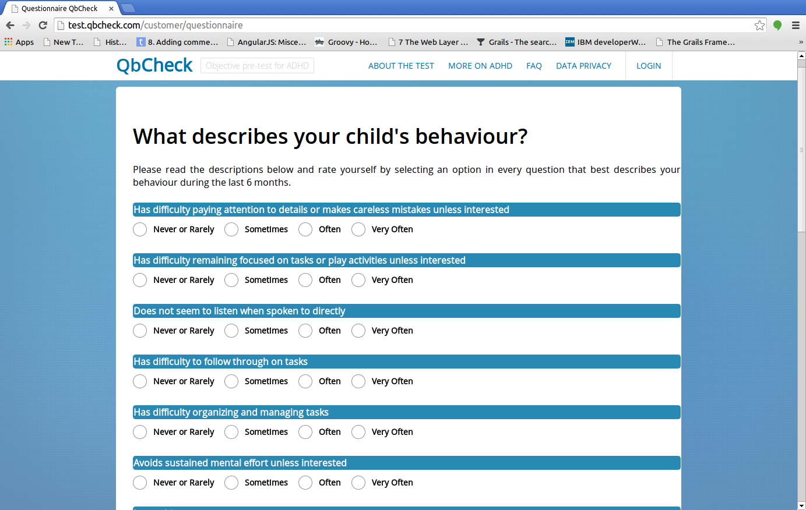

check computer

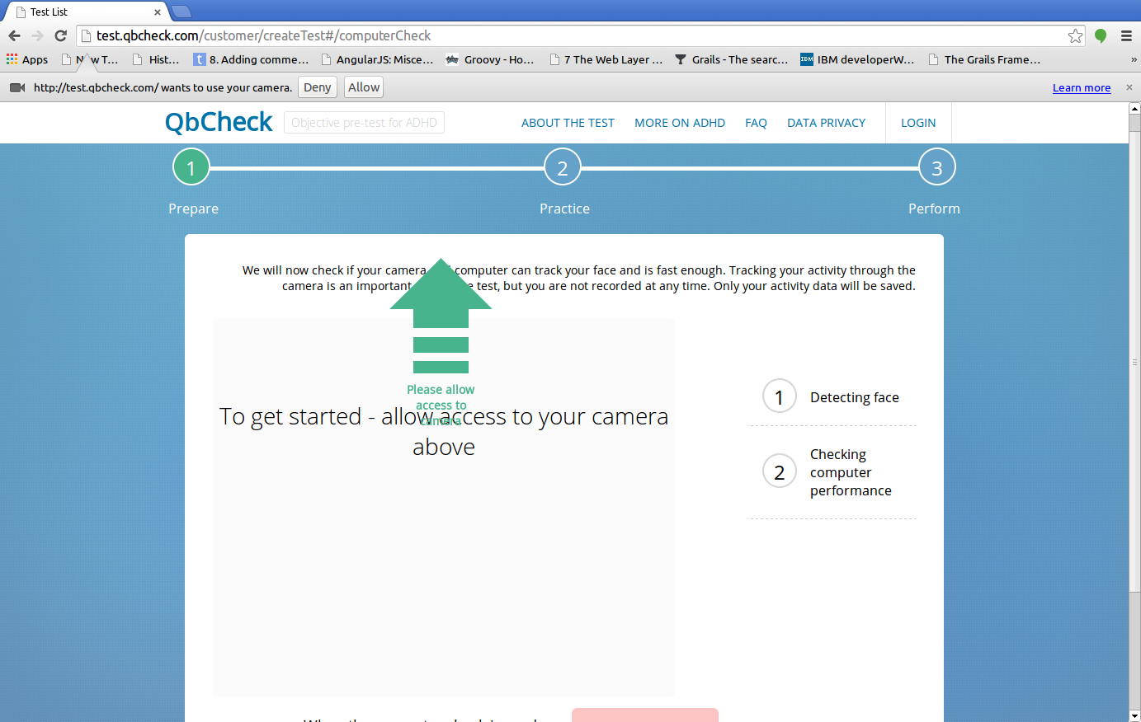

check computer

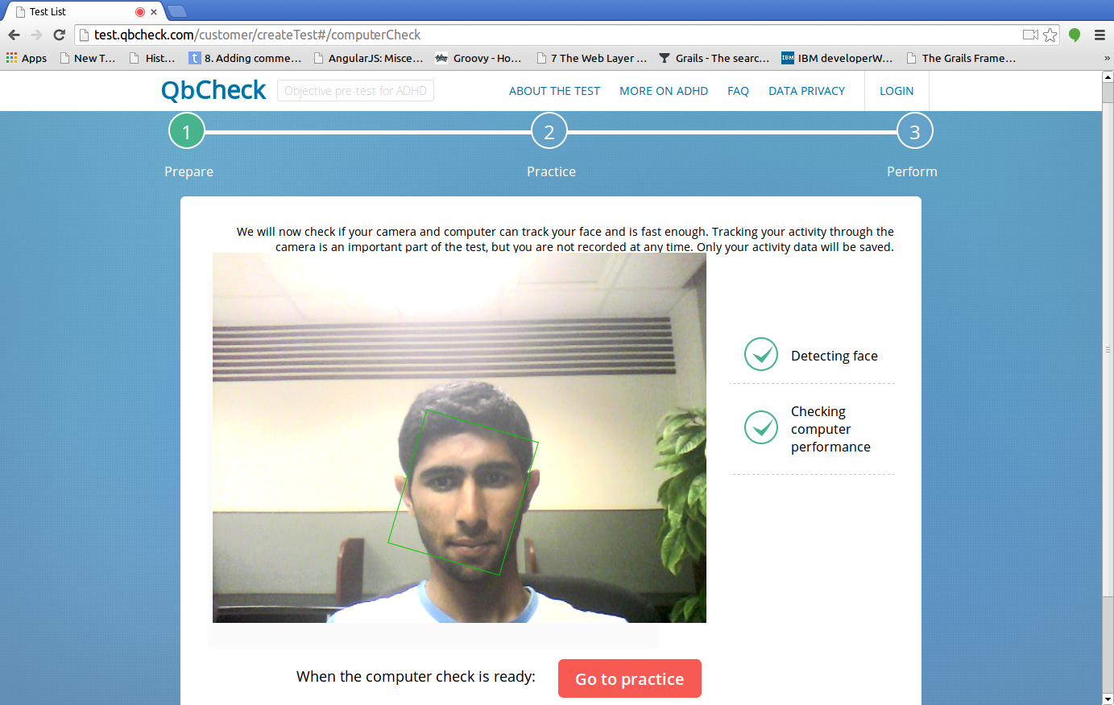

in test (full screen)



home for system admin

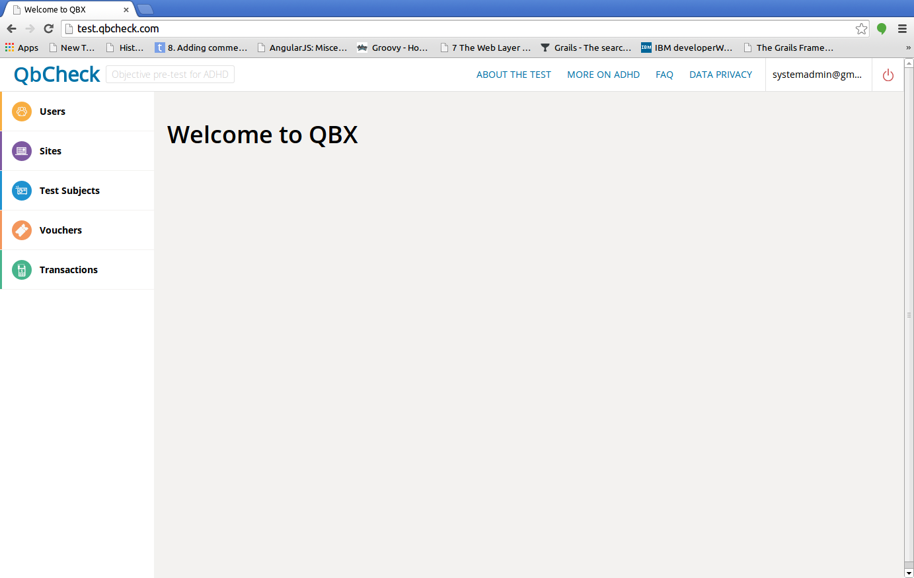

managing users

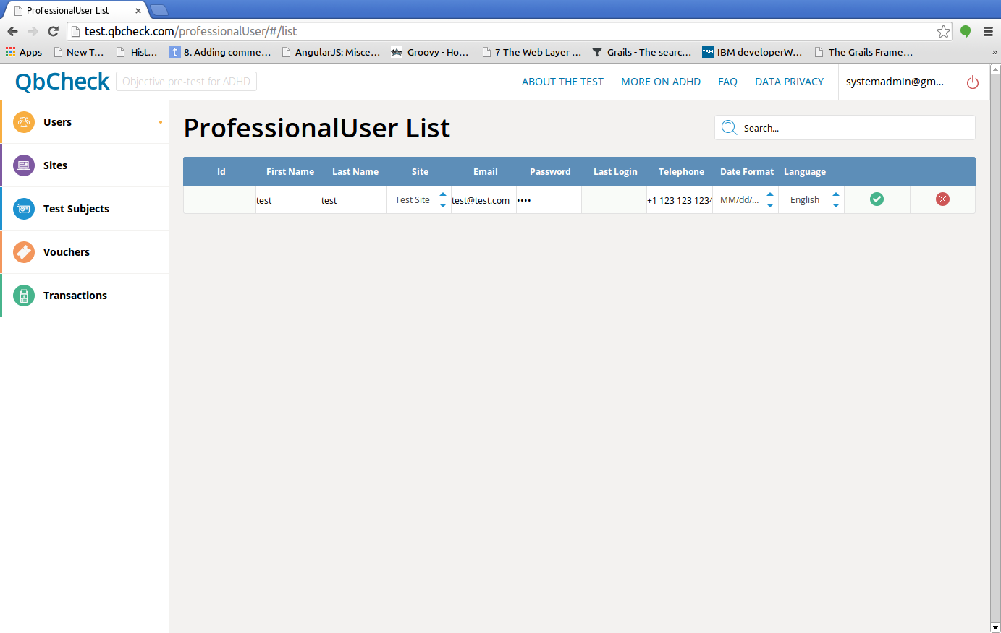

home for users

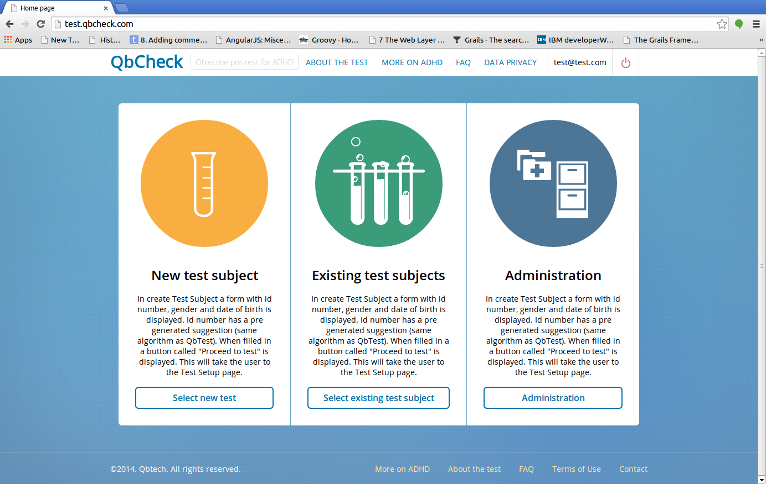

site billing information

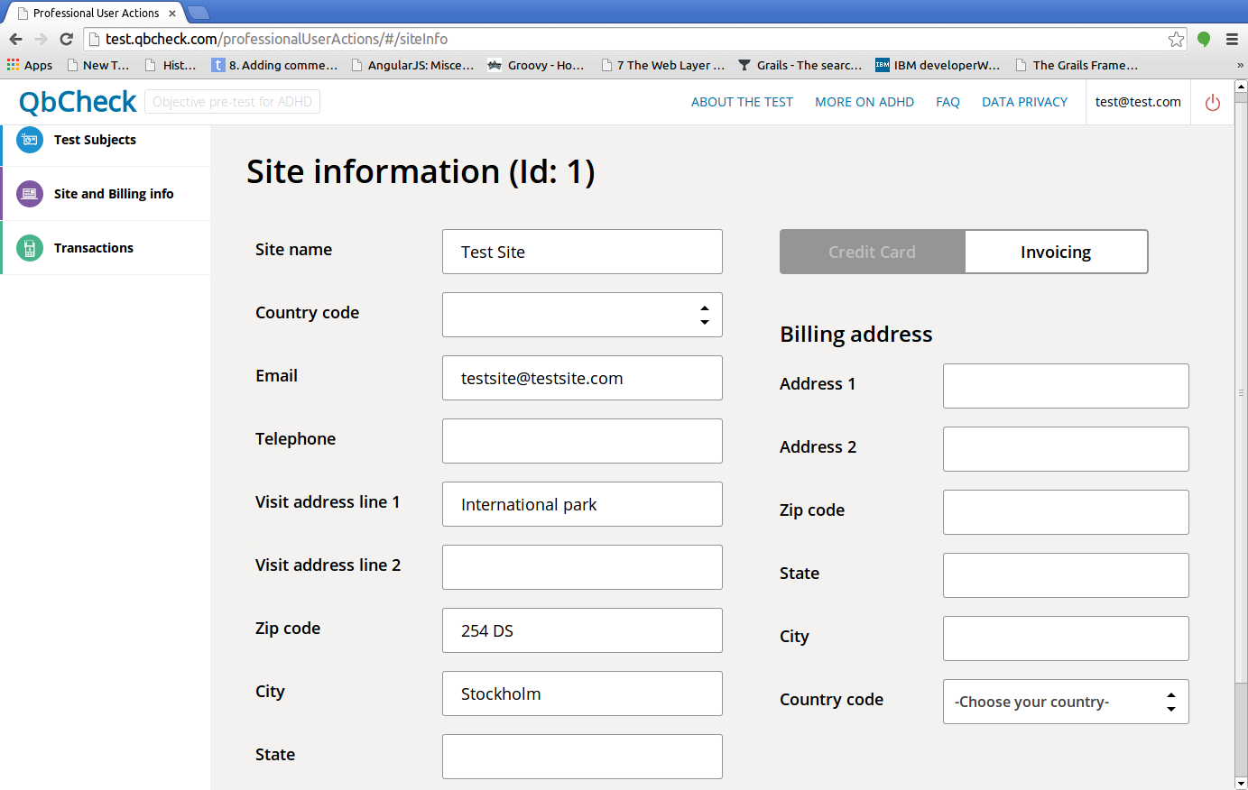

QBX business need and problems it solves.

## What is QbCheck

QbCheck is an objective online tool that measures the level of ADHD symptoms and indicates whether a person should seek professional evaluation for the condition. The objective measurement of the three core symptoms of ADHD is compared to a group of person your age and gender but without ADHD to set the context for your result.

## What does QbCheck measure?

QbCheck measures your movements and ability to pay attention and restrain impulsivity during a 15 or 20 minute test.

## What is ADHD?

ADHD, Attention-Deficit/Hyperactivity Disorder, is a common behavioral disorder affecting 3-7% of all school aged children. Of these children 30-50% continues to display symptoms into adulthood. ADHD is often described as an on-going pattern of inattention, hyperactivity and/or impulsivity that gets in the way of daily life or typical development. Since ADHD can affect a person’s ability to maintain attention, begin an activity, organize and manage tasks the condition may have negative effects on effects on social, academic and/or occupational functioning.

ADHD has its drawbacks but some symptoms can also have unexpected benefits such as creativity, intuition and/or spontaneity. Here recognizing your symptoms and understanding how to manage and balance them can be crucial in turning your weaknesses into strengths.

## What are common ADHD symptoms for children?

Common symptoms of hyperactivity and impulsivity include:

1. Talking nonstop
2. Dashing around, touching or playing with anything and everything in sight
3. Having trouble sitting still during dinner, school, and story time
4. Being very impatient
5. Having difficulty waiting for things they want

Common inattentive symptoms include:

1. Having difficulty maintaining focus on one task
2. Becoming bored with a task after only a few minutes
3. Not seeming to listen when spoken to
4. Daydreaming, becoming easily confused, and moving slowly
5. Struggling to follow instructions

## What are common ADHD symptoms for adolescents?

Common symptoms for adolescents include:

1. Having difficulty maintaining focus on one task
2. Not seeming to listen when spoken to
3. Struggling to follow instructions
4. Forgetting to bring home or turn in assignments
5. Difficulty engaging in quiet activities

## What are common ADHD symptoms for adults?

Common symptoms for adults include:

1. Problems with organization and planning
2. Difficulty paying attention
3. Difficulty initiating and completing tasks
4. Misplacing or losing items

## 

## 

## Technologies used for QbX

1. Groovy and Grails
2. HTML/HTML5
3. Javascript ( Javascript + jQuery + AngularJS + AJAX )
4. CSS
5. Hibernate
6. mysql